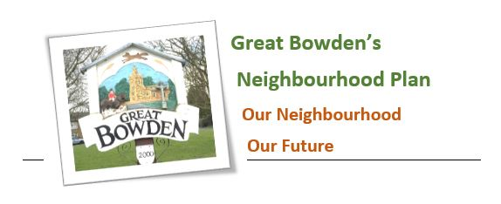

Item 10: Report from the Neighbourhood plan Monitoring and review committee.
GBPC Meeting, Wednesday 12th July 2023

As has been previously reported,, it was decided to explore new Government powers which ensure that the policies in the Neighbourhood Plan remain active and will continue to be used by Harborough District Council to determine planning applications in the Parish, even in circumstances where the Local Plan cannot offer any protection.

To take advantage of these powers, the neighbourhood plan needs to consider allocating land for small-scale, and locally appropriate residential development, within the Parish. This may, for example, be for bungalows to meet the needs of older residents, or small family homes for young couples.

It is obviously necessary for the Housing Theme Group to make contact with all landowners in the Parish to invite expressions of interest for small-scale and well-designed development which is in keeping with the character of Great Bowden.

There are three distinct groups of landowners who are to be contacted:

- The first group are residents who might have land available for suitable development. These are to be contacted by issuing a communication via the Great Bowden Newsletter. I have been in touch with Lennie Rhodes who organises the distribution team and she has agreed to include it with the next edition, to be issued at the beginning of September. There are 720 deliveries to be made.

I would suggest that GBPC makes a donation to the Newsletter of £50.00 for such a service and I would like it to be agreed at this meeting please. This does not include the cost of printing the letter.

- The second group of landowners are those who are registered of having land in and around Great Bowden.
- The third group are those landowners who who submitted sites to HDC in their call for sites to whom a similar letter will be issued.
It is hoped to complete this exercise this autumn.
Once this exercise has been completed and we understand better the aspirations of local landowners, we will consider whether or not to formally assess each site with a view to making a small-scale allocation of the most suitable site through the Neighbourhood Plan Review.

It remains a possibility, at this stage, that no suitable site will come forward and if so, the process will not be taken any further.
. Peter Mitchell
Tel: MH 466234
e-mail: peter.mitchell2@hotmail.co.uk

