OPEN SPACES REPORT

For the Parish Council Meeting on 12 July 2023

Introduction

I am grateful to all of our Open Spaces wardens, who have produced their individual reports for the PC meeting on 12 July 2023. I am grateful to Carolyn in particular, who stepped in to cover route 5, as Lynn and Gordon Mayer were struck down by covid and unable to do their walk.
I have collated the reports into this document and for ease, there is a summary of outstanding matters, below, as identified by Carolyn.

SUMMARY

Outstanding Matters (as detailed in previous OS report). These need to be addressed ASAP:

- Upper Greens: Awaiting ‘Do not drive on the grass’ signs. Have these arrived yet?
- Top of Main Street leading to Green Lane: awaiting posts/ropes as the land owned by the PC outside the ex-council houses – grass totally churned up. Can we have a timeframe for the arrival of posts to stop this problem?
- Drain by The Old Hall is still blocked.
- Rotten post further down Main St - (already reported by Open Spaces report). Could this be replaced?
- Ongoing case: Old Sawmill Development Damage to Leicester Lane verges; parking bays; road edges.

Further Action Points (arising from this report)

- PC to confirm that it will, in the next round of s.106 claims, include an application for two new benches on Leicester Lane to mark the Coronation year, to replace the two deteriorating benches (similar to those installed in the rec).
- Manor Road – common land - there is some debris that should be cleared up and looks like it was a result of recent building work on the neighbouring property. Can the PC write to the occupants of the house in question and politely request that the debris is cleared?
- To keep an eye on the posts on the green outside the Shoulder of Mutton – they have some strimmer damage. They are not in need of urgent repair but need to be monitored.
- There is enclosed land on the village green (please see report of Chris Attenborough) that is registered as common land. Why is it enclosed?
- The reseeding before the bus stop (at the Welham road / Langton road corner) has still not established well and requires some attention. Who can facilitate this?
- The ground on Welham Road is slowly recovering and it may be the intention to allow nature to take its course. However, there are hollows next to pavement which ought to filled to eliminate tripping hazards. Waste materials need to be removed. Who can the PC speak to about this?
- Berry Close – broken fence is causing a safety issue. Who can the PC speak to about this?
Detailed Route Reports

Routes 1 & 2 – Carolyn Ford

Route 1 (Leicester Lane inc Heathcote Grange & allotments; Top Yard area and bottom of Burnmill Rd to village boundary; Main Street from Burnmill Rd to railway bridge both sides)
Route 2 (Green Lane + Upper Green Place (whole of, except frontage on Main St is in Route 1)

Leicester Lane

- All road edges on LL continue to deteriorate; creating more hazards for cyclists and motorcyclists – see below. The worst degradation is on the outbound side from approx the Heathcote Grange entrance to Great Bowden Hall. Can the state of the road edge be raised with Highways again please?
- Pleasing to note that LCC Forestry’s contractors have ground-off three tree stumps of felled White-flowering Chestnut (Aesculus_hippocastanum); a task we’ve been chasing-up with Stewart Marshall for a while. Hopeful, therefore, that replacements will be planted this October/November and can be noted in some manner (tags/signage?) to mark Coronation Year.
- A reminder to the PC that we would like two replacement benches (again to mark Coronation Year) included the next round of S106 claims to replace the deteriorating and now dangerous HDC ones – see below. Benches to be as per the ones purchased for the Rec. (Will require negotiation with LCC via HDC re replacing them under the existing Licencing.)
- Footfall on both sides of the Lane continues to be high.

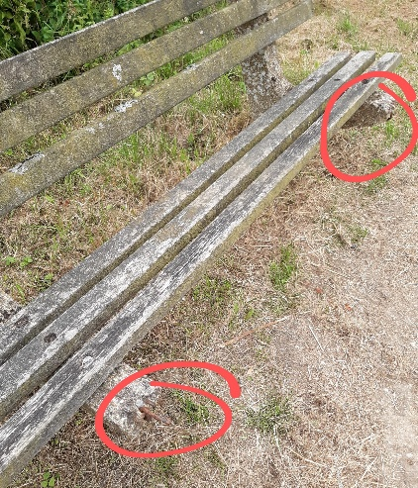
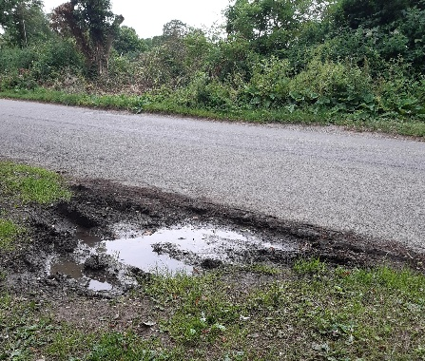
Heathcote Grange/Barwood/Cora Specific:

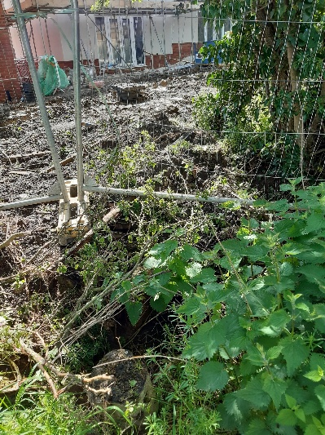
Barwood/Cora specific issue – the 5 metre corridor – about 2m in reality - which Mulberry were conditioned to leave as a wildlife - ‘environmental gain’ - corridor on the eastern side of their site (boundary with Saw Mill) is being decimated during construction. Without going back through plans, I am as certain as I can be that the boundary hedge had to remain in situ. Now look at the state of it – photo left.
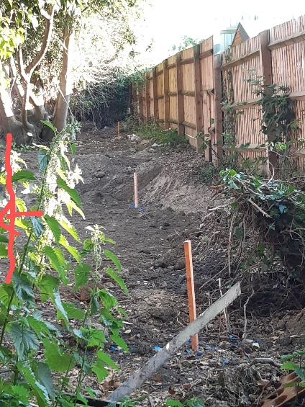
Update: Barwood/Cora’s land grab action resulted in a boundary dispute with the adjoining residents – I was able to supply historic data including Land Registry docs for Bowden Fencing. Next photo shows the extent (on 15 June) of the land grab – basically Barwood/Cora claiming all of the environmental buffer of the Heathcote Grange estate of the estate’s eastern side.

In my estimation the correct boundary is to the left of the red arrow in pic on right.

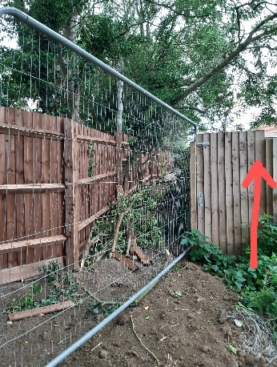
Partial inspection of current state on 4 July shows as below left which, given the Mulberry boundary is approx where marked by vertical red arrow in photo below, looks to have returned a significant section the ‘environmental gain’ buffer. I doubt it is the correct width of buffer but better than the ‘claim’ shown by ground pegs in photo the right. (I need to inspect again wearing gloves in order to ‘adjust’ the Heras and gain entry.)

Until such time as the LPA has a proper inspection and enforcement regime local developers will continue to push every boundary (literally and figuratively) in pursuit of expedient solutions to the density/layout difficulties they themselves create and which planners fail to mitigate.

Barwood Homes (now Cora) – Old Sawmill development

1 Severe damage to Leicester Lane verges, parking bays, road edges, etc – action already taken
- By Cllr Champion, myself and Phil Andrews, LCC’s Streetworks Inspector.
  - Second update: the first licence obtained for the work was cancelled by RM Contractors; the second licence under the same numbers:
GQ550HMS887819 Permit ref:GQ550HMS887819-02

  - Due to operate – with traffic control: 9 to 11 May

  - Third update (9 May) contractors have arrived on site and traffic control in place; remains to be seen how much ‘remediation’ takes place and to what standard.

  - Fourth update (10 May) – what can you say about this which doesn’t contain expletives? See R M Contractors’ idea of adequate remediation here:
https://photos.app.goo.gl/4ELrfcKD1FkQktCC9

  - Fifth update (early June) RM contractors escape blame when western Power Distribution’s contractors arrive early June to tear up the same piece of verge!
    - We await further remediation via the Streetworks Inspectors’ powers! Kier’s standard of work is just as dire as that of the previous contractors – how our mowing contractor is supposed to safely mow over a surface left strewn as shown below is beyond me. They even leave the hazard tapes buried in the backfill!
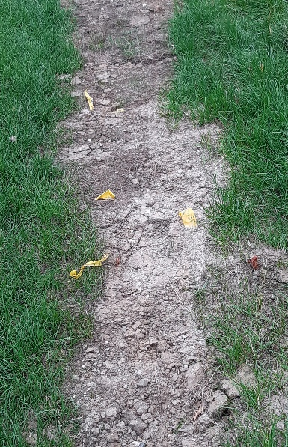
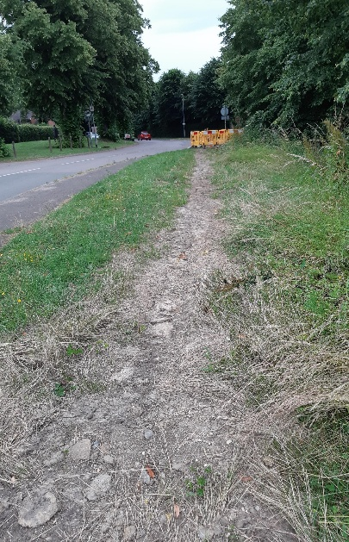

2 Application for a Variation of Conditions to extend the working hours on Saturdays to from 13:00 finish to 18:00 finish
- First application was withdrawn due to the application docs being ‘gobbledegook’ and erroneously quoting Condition 5 (Soil Contamination)
- Second application has arrived as a Discharge of Conditions application – see 23/00625/PCD – I have asked Phil Knowles to ‘call this in’ for residents. Firstly, it should not be a ‘Discharge’ but a ‘Variation of Conditions’ and secondly, if our call in is granted (now confirmed), we’re going to make them work for it!
- HDC decision Notice of 4 July (posted to portal 5 July) states:
Part II - Particulars of decision
Reason
Condition 8 (Construction Environmental Management Plan) is NOT DISCHARGED.
Site working of any kind is not acceptable on Saturday afternoon on residential amenity grounds.
A Eastwood, Development Planning Manager

3 Green Lane – Barwood/Cora - action is ongoing

- Contractors are still parking in the adjacent field under permitted development rights;
- The spoil heap (see photo) has lessened and is no longer a danger to walkers using the A63 footpath; the area is now a site overflow dumping ground and source of litter; when I make time I will check with the local LCC footpaths officer re when the diversion permit ceases. Monitoring to continue.
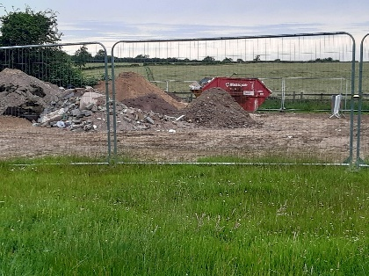
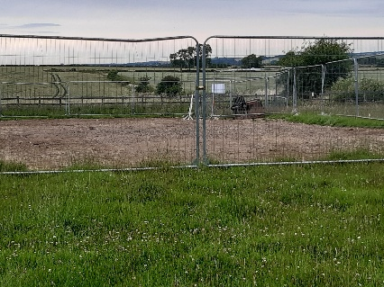

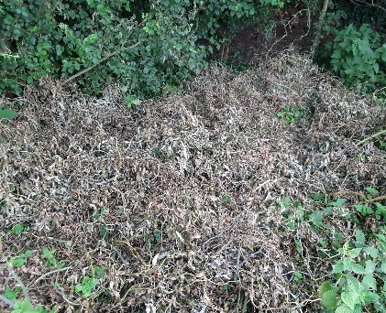
Green Lane (the byway) and Upper Greens footpaths
- Some green waste being dumped in Green Lane at each end (example see left) – almost certainly local in origin;
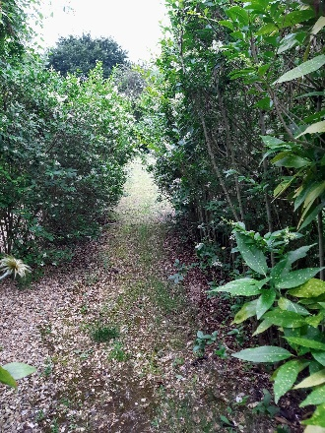
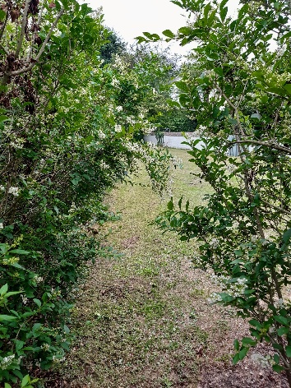
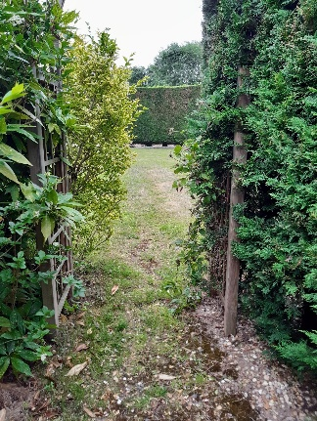
- Note: Upper Green footpath walked 4 July and recorded (see below) – please walk often.

Main Street itself
- Some improvement re hedges that overhang the footpath – a couple of hedges have been cut back;
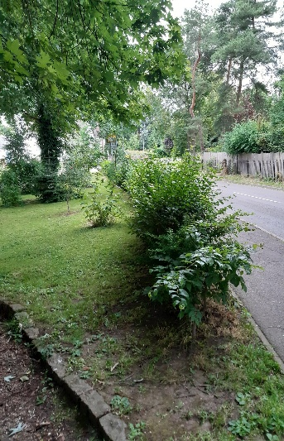
- As noted previously (often) this open space (Neighbourhood Plan Policy: other open spaces) is rapidly becoming an enclosed garden. (See left.)

Main St, Wildflower verges
- Ongoing monitoring;
- Very successful season for our Yellow Rattle (Rhinanthus minor) – much seed on the triangular verge;
- These verges will be hand cut sometime during August – date to be agreed.

Routes 3 & 6 - Chris Attenborough

Main Street from bridge to junction with Lang Rd excluding Gunnsbrook Close itself; Manor Rd: both sides, verges & open spaces (Common land by Chater: SP 74419 88701) (Common land between Langton Road & Manor Road SP 74399 88955); Langton Rd: from Main St/The Green end to junction of Welham Rd; both sides, etc. (Common Land at Langton Road SP 74444 88865).

The walk was conducted on 26th June with the following route. The walk takes approximately 1 hour with some photos and 30 mins to organise and write up the report.

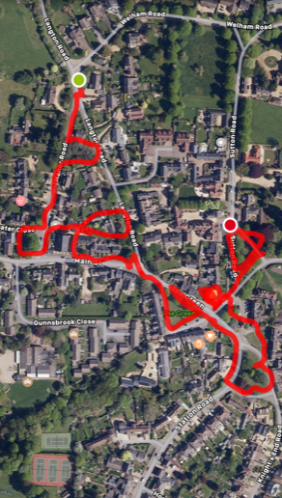

Points to note.

- Manor Road common land - as previously reported, there is the ivy covering the trees, probably very good for wildlife but for awareness. The paths either side could be a good location for selective community gardening, planting or wildflowers. They were walked and freely accessible. There is some debris that should be cleared up and looks like it was a result of recent building work on the neighbouring property.
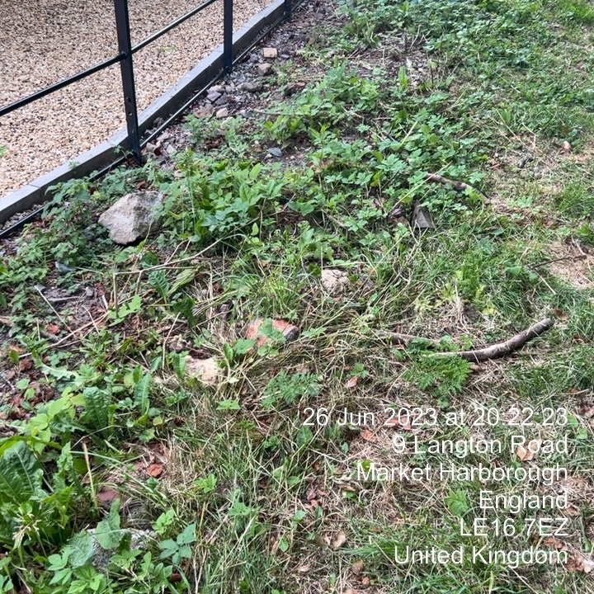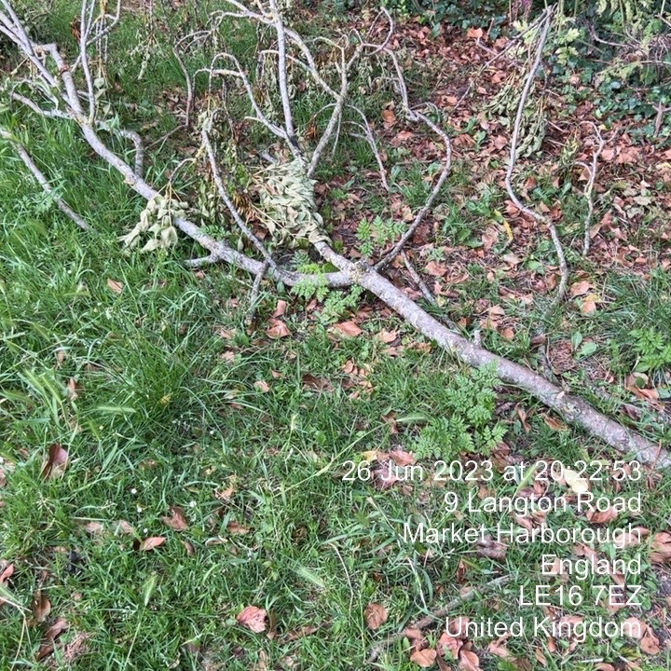

- 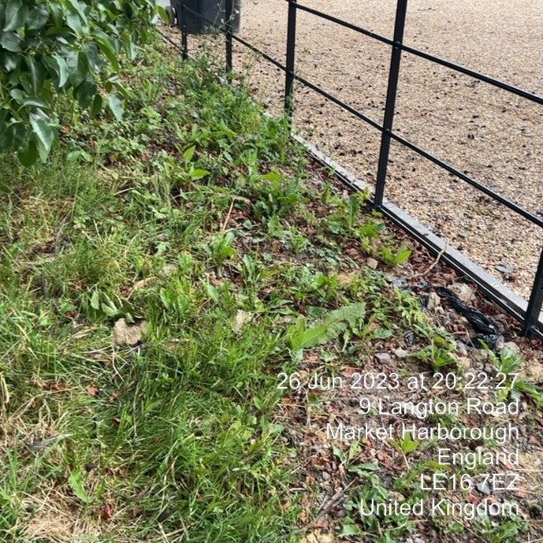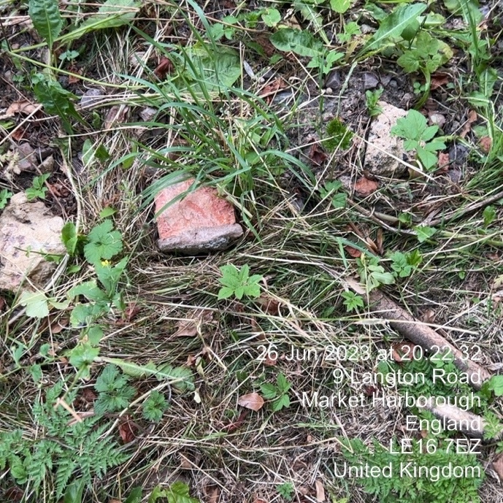

The development of the adjoining property has completed and there are no remaining concerns regarding boundary intrusion.

- Chatter Close Common Land, as previously reported – verge is impacted by parking and some rocks though not a major issue (old photo).

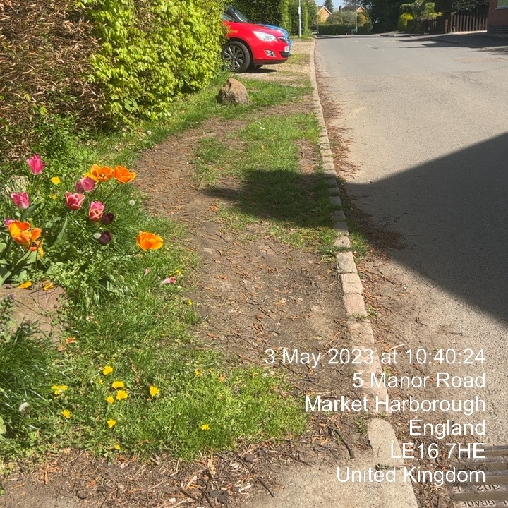

- All posts inspected. None were found to be in urgent need of repair and none were excessively loose. A couple need monitoring. Some of the posts look as though they have strimmer damage. Repeated strimming into the posts is going to shorten the life of them.

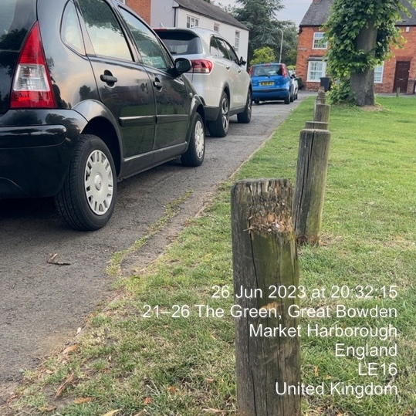

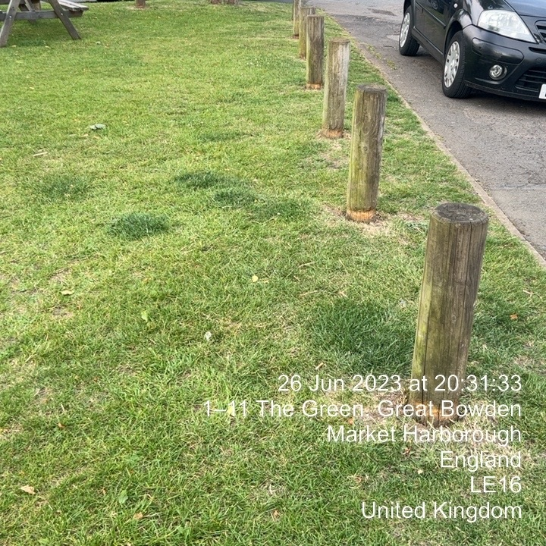
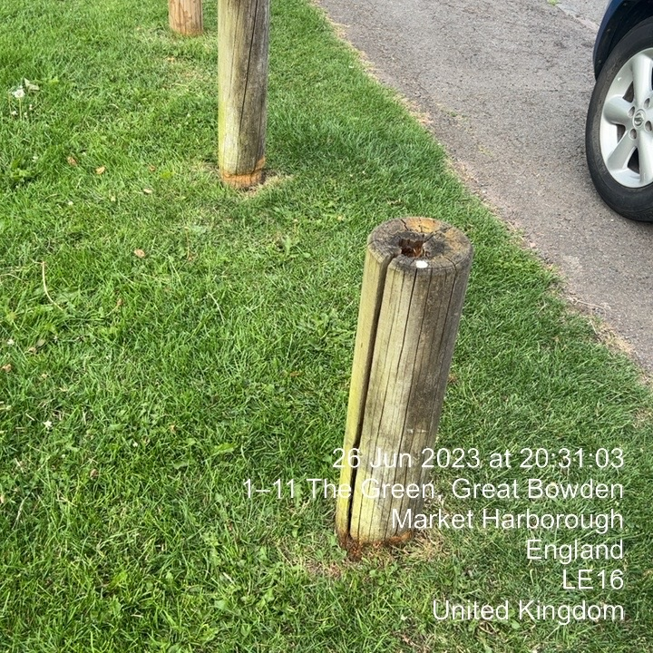

- All footpaths now adequately sign-posted and all found to be clear and accessible. These are the footpaths between main street, manor road and Langton road.
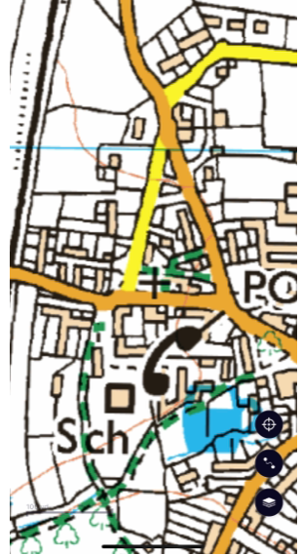
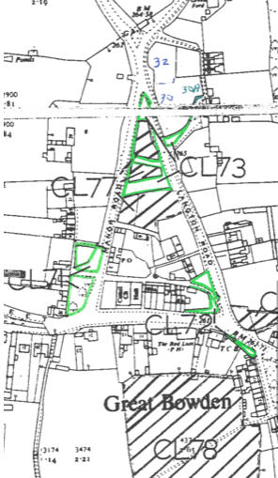

- The common land, which still seems to still appear as common land on the Village Green maps as held by LCC solicitors, CL71 still spears to be registered as common land but is currently enclosed and has been for some time?

- Other common lands were visited and observed as being as per the register - CL72, CL73, CL74, CL77.

- Ground here seems to have improved and is going well.

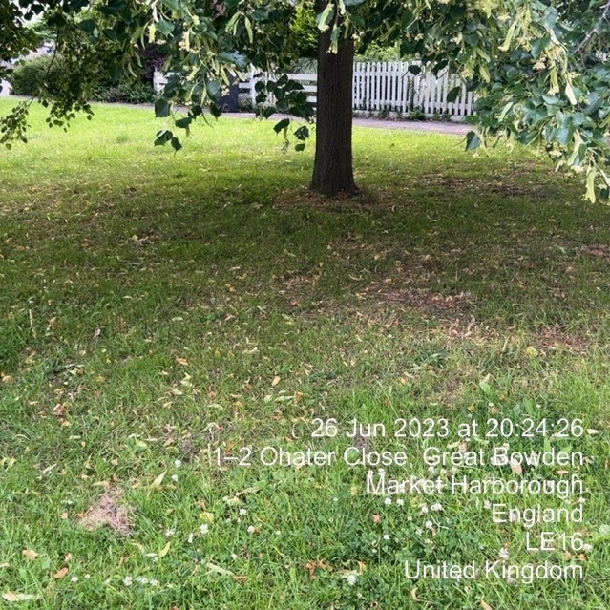

- The reseeding before the bus stop (at the Welham road / Langton road corner) has still not established well and requires some attention.

I am not sure whether the footpath along Langton road is a temporary path and in line with the intent / planning permission but it seems a little odd and I doubt would never entirely cover without topsoil of this is the intention.

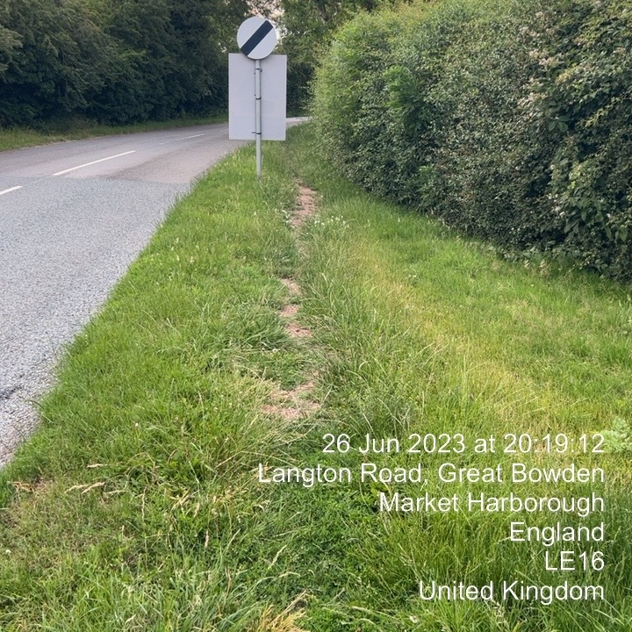

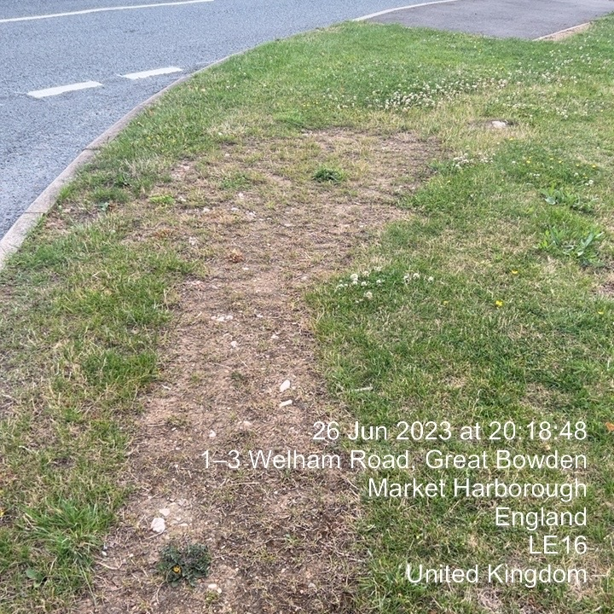

Route 4 - Jim Culkin
1. Hursley Park.
There are no issues to report. The wild flower meadow is looking very attractive and the new path ways mowed across the park provide for a pleasant extensive walk. Itʼa credit to the estate.
2. Welham Lane.
There is minor visible litter, although it and fly tipping are probably hidden by the summer growth.
Some of the trees adjacent Hursley Park are dying and the branches overhanging the road will at some point become a hazard to road users.
3. Welham Road.
The ground is slowly recovering and it may be intention to allow nature to take its course. However, there are hollows next to pavement which ought to filled to eliminate tripping hazards. Waste materials need to be removed.
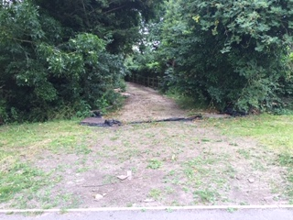

Route 5 – Carolyn Ford

Nothing major to report.
Usual amount of litter on Dingley Road.

Footpath from Churchyard to Lime Tree Place is the driest and tidiest I've seen in a goodly while. I have concerns (as always) about the building site on the other side of the listed mud wall. On the site side there is much vegetation close to the wall. This requires hand clearance - nasty 'accidents' occur when JCBs are used in such situations! Not certain how one might ensure it's appropriately cleared.

Walked the enclosed common - photo attached.

Entrance to Lime Tree House, Sutton Rd, is on our watch list and should remain so.
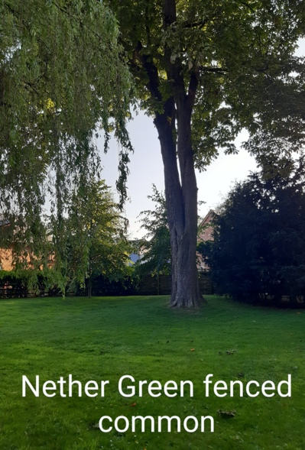

Route 8 – John Coombs [Knights End Road, Horseshoe Lane, Station Road both sides from the Recreation Ground entrance to the railway bridge, taking in Madeline Close, Countryman Mews, and Bankfield Drive near the railway bridge. The whole of Berry Close and Berry Close new estate including the play area and SUDS.]

Berry Close
SUDS
Photo 1 shows the green algae on the surface of the retention pond. I think this must be a seasonal issue as if you look at Photo 2, there is plenty of reed and other plant growth.
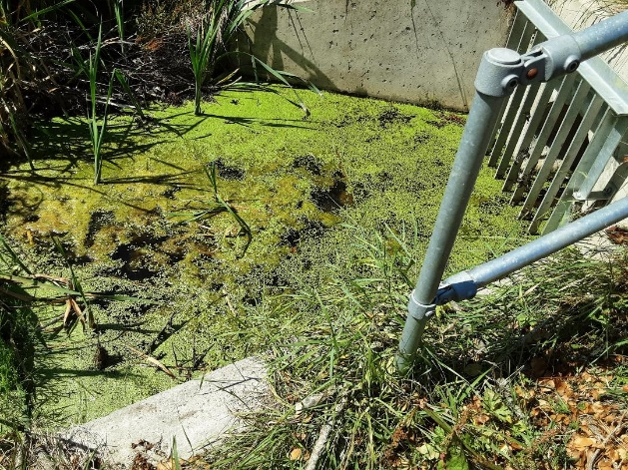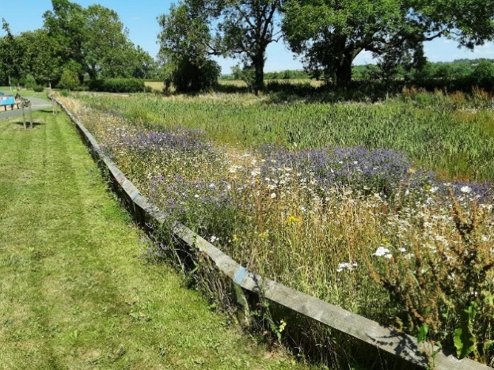
Photo 1 Photo2
The outlet grill at the culvert is clear for water to pass into the pipe network.
The outer edge of the grass area near the culvert head has recently been trimmed, though not as well as previous times. As you can see in Photo 3, the wooden fencing at this point has been damaged and this may have been hit by the cutting machinery. This needs to be fixed as it may be considered as a safety issue.

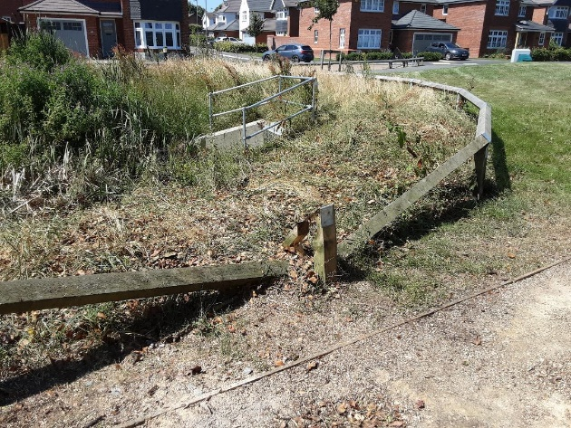
Photo 3

Station Road – Hedges

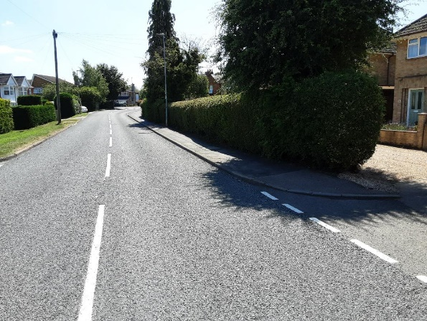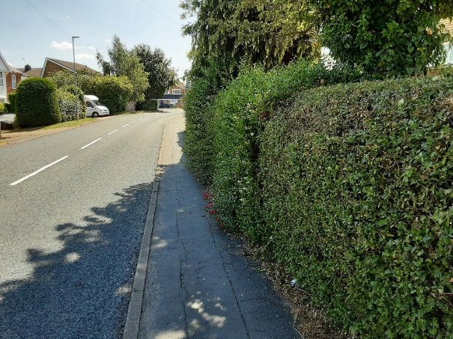
Photo 4 Photo 5
Photos 4 and 5 show the hedges on Station Road opposite Berry Close. They are usually well maintained by the residents with no encroachment onto the footpath. At the moment, there is a central section that is encroaching and reducing the accessible footpath width. I think each resident must do a section but whoever does the middle bit is either on holiday or unable to do so. Not much we can do at the moment as it may get sorted.

Footpath linking Station Road to Berry Close.
I am not sure who is responsibly for the maintenance of this path. As you can see on Photo 6, there is a lot of weed and nettle growth which is starting to restrict the useable footpath width.
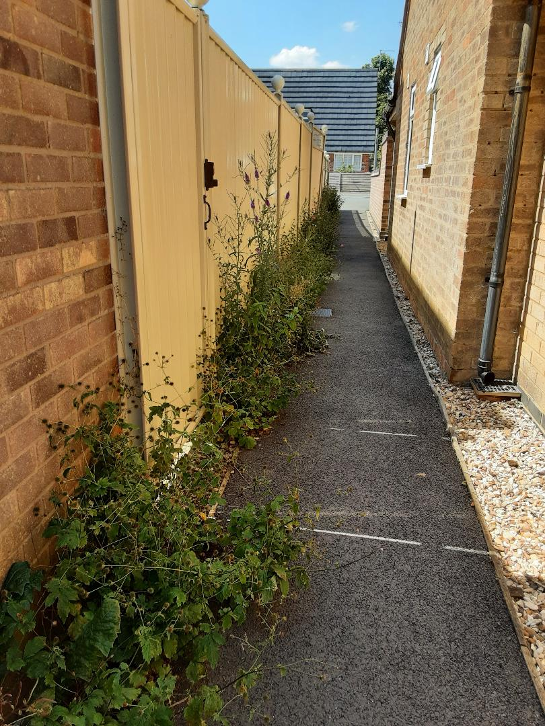
Photo 6

