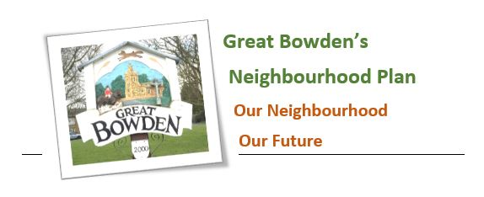

Item 10: Report from the Neighbourhood plan Monitoring and review committee.
GBPC Meeting, Wednesday 13th September 2023

Big thanks to Lennie Rhodes and her team for delivering the residents’ letter with August’s Newsletter which requested small sites for development. In total 720 letters were delivered.

We have received notification from one resident that they own a site that might be of interest. Paul and I will meet up with this resident in the near future to discuss. We have also received a request from a resident to join the NP Monitoring & Review Committee.

It’s planned to have a catch up meeting with our consultant over the next few days to discuss how best to contact the second group of landowners who are registered of having land in and around Great Bowden.and the third group of landowners who have submitted sites to HDC. It is hoped to complete this exercise this autumn.

It remains a possibility, that no suitable site will come forward and if so, the process will not be taken any further.
. Peter Mitchell
Tel: MH 466234
e-mail: peter.mitchell2@hotmail.co.uk

