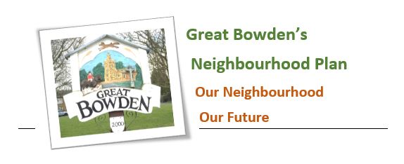

Item 10: Report from the Neighbourhood plan Monitoring and review committee.
GBPC Meeting, Wednesday 8th November 2023

I am very pleased to say that the Parish Council has succeeded to obtain additional funding of £8000 which will enable us to complete our neighbourhood plan review.

Not only that, but we have also succeeded to obtain a technical support package that will allow a professional company, AECOM, to advise on producing a new housing design code for Great Bowden. This will set simple, concise design requirements and will use visual and numerical information. This is to ensure that any future development is in keeping and maintains and enhances Great Bowden’s distinctive character.

As you know, it has been decided to explore new Government powers which ensure that the policies in the Neighbourhood Plan remain active and will continue to be used by Harborough District Council to determine planning applications in the Parish, even in circumstances where the Local Plan cannot offer any protection.

To take advantage of these powers, we are considering allocating land for small-scale, and locally appropriate residential development, within the Parish.

A meeting took place with a resident who owns a site that might be of interest. This site will be reviewed by AECOM as to its suitability.

A catch up meeting took place with our consultant, Gary Kirk, to discuss how best to contact the second group of landowners who are registered of having land in and around Great Bowden.and the third group of landowners who have submitted sites to HDC. Gary stated that he would follow these through

It remains a possibility, that no suitable site will come forward and if so, the process will not be taken any further.

. Peter Mitchell
Tel: MH 466234
e-mail: peter.mitchell2@hotmail.co.uk

