Open Spaces Report

For the PC Meeting on 8th November 2023

This report will be more brief than usual. This is my fault and certainly not the fault of those who kindly conduct the walks!

Bob Hooper had no issues to report on his route.

Jim Culkin has reported as follows:

- Hursley Park.
Nothing to Report. The central green, green spaces and park are in good order. The summer grasses have been mowed and the cutting removed. There no issues with the play equipment.
- Welham Lane.
The is no fly tipping. There is a small amount of litter, can and bottle mainly, but over all the lane is looking good
- Welham Road.
The entrance to the development site is still a problem. The plastic sheeting needs to be removed before it gets buried.
The fallen tree adjacent the entrance is not a danger or obstruction to the public or the verge. The tree is covered in ivy so an option is to leave it and manage it as an ivy hedge and allow it to become a natural habitat for wild life, as part of a village policy of greening up the village.
Carolyn Ford has reported as follows:
For PC Meeting – 8 November 2023

Update on routes 1 & 2 – Carolyn Ford
Route 1 (Leicester Lane inc Heathcote Grange & allotments; Top Yard area and bottom of Burnmill Rd to village boundary; Main Street from Burnmill Rd to railway bridge both sides)
Route 2 (Green Lane + Upper Green Place (whole of, except frontage on Main St is in Route 1)

These items, copied from the July previously ‘outstanding list’ are perhaps still... outstanding?

- Upper Greens: Awaiting ‘Do not drive on the grass’ signs. Have these arrived yet?
- Rotten post further down Main St - (already reported by Open Spaces report). Awaiting replacement – or awaiting a ‘Do not drive...’ sign?.
-----------------------
Leicester Lane

- The road edges on LL continue to deteriorate (see below) causing hazards for unsuspecting motorists and cyclists. The worst instances are on the outbound side from approx the Heathcote Grange entrance to Great Bowden Hall. As a for instance, given the recent deluge, the photo below right (taken late Sunday pm) indicates the depth of the worst pot-holes/road edge degradations – very dangerous for cyclists of any kind who are forced over to the edge of the road by passing traffic. Were these issues raised with Highways Maintenance as a result of the last report... and the one before, before?
- Re two replacement benches (to mark Coronation Year) – mysteriously umm... disassembled and disappeared without trace during the early hours of 16 September... and which benches we previously agreed to be included in the next round of S106 claims... (This is on the Agenda so I’ll speak to it at that time.)
- Even during wet weather, Footfall on both sides of the Lane continues to be high.

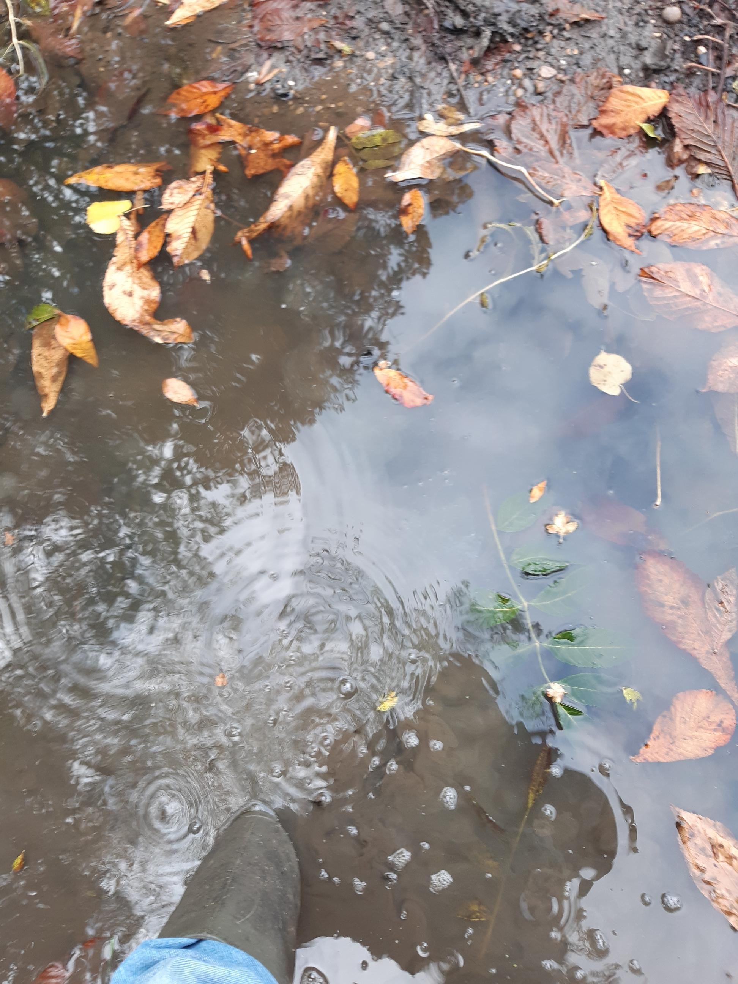
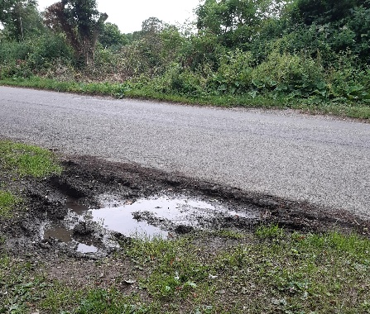
A48 footpath as accessed from Leicester Lane: an ongoing issue with antisocial behaviour(?) – viz, motocross bikes tearing up and down both the northern and southern parts of the path and into the arable crops. On 4 August we noted a different incident involving a group with a quadbike - this resulted in criminal damage to the landowner’s fencing and Highways footpath signage. (The Police recorded it as ‘antisocial behaviour’ – case number 230004843331.) Having been alerted, the criminal damage was rapidly repaired by the landowner’s tenant.
Subsequently Lynn Mayer (Heathcote) and myself had a meeting with John Gray, the LCC Footpaths Officer for our area. The nuisance seems capable of swift resolution, at least on the northern stretch of the footpath. I have a request for at least some matched funding on the 8 November Agenda so will speak to this issue at the meeting.

Heathcote Grange/Barwood/Cora Specific:

No time for a thorough look but a swift inspection shows increasing and pleasing maturity in the ecologically valuable SUDSs area. The rushes are increasing in number and the patch of clear water at the outflow is slowly increasing.
Not entirely happy with the security/fixing of the benches in our Leicester Lane Play area but I believe the site is due a RoSPA inspection soon?

Barwood Homes (now Cora) – Old Sawmill development – now, apart from ‘snagging’ and the removal of the last skip, the site is finished. And are we all thankful for this? I’ll say!)

Severe damage to Leicester Lane verges, parking bays, road edges, etc – action already taken
- By Cllr Champion, myself and Phil Andrews, LCC’s Streetworks Inspector.
  - Second update: the first licence obtained for the work was cancelled by RM Contractors; the second licence under the same numbers:
GQ550HMS887819 Permit ref:GQ550HMS887819-02

  - Due to operate – with traffic control: 9 to 11 May

  - Third update (9 May) contractors have arrived on site and traffic control in place; remains to be seen how much ‘remediation’ takes place and to what standard.

  - Fourth update (10 May) – what can you say about this which doesn’t contain expletives? See R M Contractors’ idea of adequate remediation here:
https://photos.app.goo.gl/4ELrfcKD1FkQktCC9

  - Fifth update (early June) RM contractors escape blame when western Power Distribution’s contractors arrive early June to tear up the same piece of verge! We await further remediation via the Streetworks Inspectors’ powers! Kier’s standard of work is just as dire as that of the previous contractors – how our mowing contractor is supposed to safely mow over a surface left strewn as shown below is beyond me. They even leave the hazard tapes buried in the backfill! (See photos in previous report.)

  - Sixth update (August) and believe me, this remediation work is every bit as tedious to get rectified as it is to read about!
In the interim, Cadent Gas had a ‘verge event’ when they replaced a gas main on the opposite side of the road; their remediation has been judged satisfactory. Meanwhile we still await remediation of the damage done by Kier, Western Power Distribution’s contractors. The latest report from Phil Andrews to Barry Champion and myself is:
Cadent Gas completed their works, and on inspection, they had reinstated the verge accordingly where they had set up their cabin etc, this had been cleared with topsoil and seed reinstated.
Following the above, I notified NG Power via email and associated issued reinstatement defect, informing them, as Cadent had now left site, they could now submit a remedial permit for approval to rectify the verge trench etc via blading/scraping the surface level/removal of all aggregate and topsoiling and seeding. This is in the process of being resolved as I have been informed by NG Power, they will submitting a permit for the remedials in accordance with their works programme.
Please be assured, I will make sure this is concluded in due course. [Ends]
  - Seventh update (18 October)
Good morning both.
Just an update as I didn’t want you thinking I had put this on the back burner. I recently found out, due to me chasing these verge remedials, the National Grid Power project manager who I have been dealing with this, is unfortunately on sick leave due to a health scare.
I have now stressed to NGP this needs actioning as the defect is well over its sell buy date! They will be raising a permit in due course to complete the verge remedials.
I will keep you in the loop.
Regards.
NRSWA/Permit Compliance Inspector
Comment: hell will certainly freeze before this issue is resolved – daily it becomes more difficult and less ‘doable’. (Which is probably the situation being engineered by national Grid/Western Power Distribution.)

Upper Greens

- Note: Upper Green footpath walked Sunday 6 November and photographic record made. Please walk this historic highway/footpath often – it must be kept open.
- Still awaiting the Keep Off/soft verges signs – (white van) traffic still crossing the common land and churning it up – among other things, this activity makes it difficult for our contractor to cut in the spring:
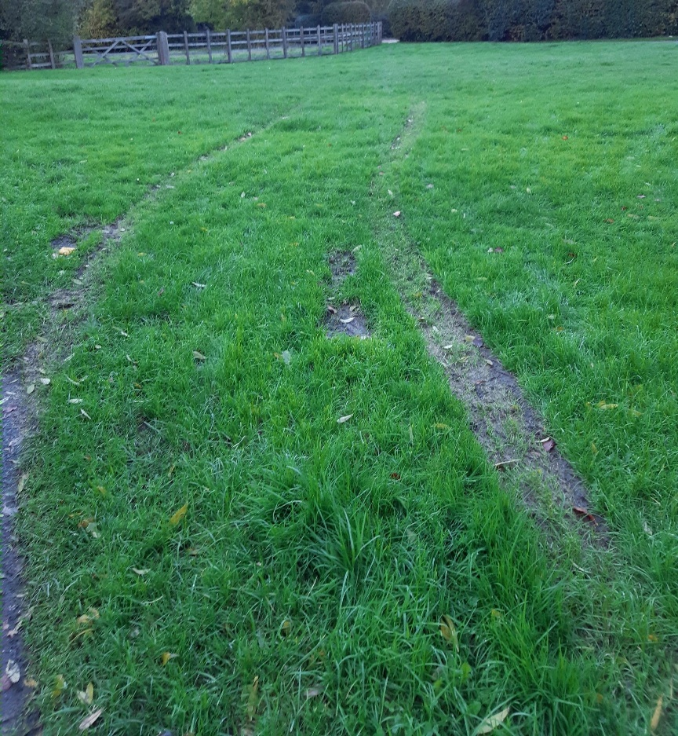

Main Street itself
- Parking in front of Nos 102 -108 – ‘on grass’ parking seems to have lessened. Presumably the proposed letter was sent?
- Some ‘on grass’ parking has resumed outside of 83/84/5 (residents not builders).
- As noted previously the open space just over the railway bridge (part of our Neighbourhood Plan Policy: other open spaces) is rapidly becoming an enclosed garden. (I keep reporting it – and walking through it as it is an open verge – thus an historic record may be required if an adverse possession situation arises.)

Main St, Wildflower verges

- The verges were raked, cut and raked and cut again during October – I’m tempted to rake and cut once more due to the prevalence this year of creeping bent grass (Agrostis stolonifera) – if not in a fine weather patch during November, then it will have to be done very early spring.


Very successful season for our Yellow Rattle (Rhinanthus minor) – and a first for us, a Bee Orchid (Ophrys apifera) growing on the triangular verge.

- At some point in the near future LCC Highways will install some ‘Way Markers’ to go with the Blue Hearts – Clerk has been copied-in on the correspondence. (Apparently this is a County-wide wildlife verges marking scheme.)

Anna Bowes
8th November 2023

