Leicestershire’s Chief Constable position is yet to be filled, and the responsibility has fallen to 749 David Sandall is to temporally manage the role as Acting Chief Constable while a suitable applicant is sought. During this transition period, ACC Sandall has released this brief statement regarding ‘The Policing Pledge’ and ‘Standards of Delivery’.
ACC 749 David Sandall
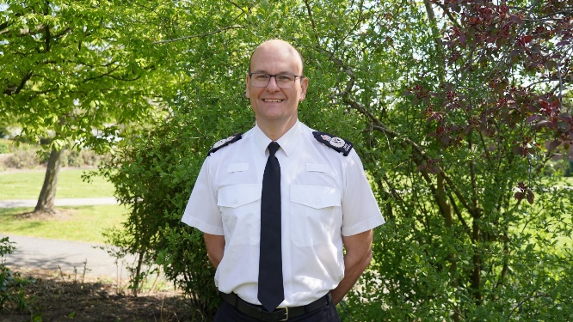

“The Policing Pledge defines our role as an emergency service, it protects our
communities, maintains the peace and prevents and detects crime. Our focus remains the same, to catch criminals and bring to justice those that do us harm.
The Police and Crime Commissioner has set a local Police and crime plan,
that we are already delivering. Therefore, I currently don’t intend to change our vision, strategic aims, Policing Pledge or our Service Delivery standards.
On the 1st of July the ‘Safer Summer’ initiative was launched which is linked to the
Government’s own initiative to tackle ASB, robbery and retail crime in
town centres. This is part of the funding that we have been applying for via the
Home Office and as a result we will be moving 23 officers into Local
Neighbourhoods to deliver what is needed to meet the funding requirement”.

This month is the launch of our new Police crest. Following national
guidance from the Cabinet Office, it is mandatory for all forces to update their
crests to include the King’s Crown.


CRIME and INCIDENT REPORT
There has been a total of 19 of crimes and incidents that have been reported for Great Bowden in the last 8 weeks.
8 of these are not for public interest, but I can say that there has been a total of 3 road traffic collisions, two of these where injuries sustained were minor and the other, which was a motor cyclist, has potentially serious injuries.
One resident has reported that there were two males in a car parked outside their house, with the occupants inside the vehicle inhaling the gas from nitrous cartridges. A vehicle registration was passed and was checked out and came back to someone living outside of Leicestershire. There was no Police/PCSO to attend at the time of the call.
Another call came from a resident reporting that they assume the driver of a vehicle passing through the village was either drink or drug driving as he was swerving all over the road and hitting kerbs. No vehicle registration was obtained from the caller.
Police had reports of two males ‘snooping’ around a home that is currently under renovation, a neighbour spotted them and sent them on their way. This may have been opportunists looking for tools or equipment to steal and sell on.
One very strange and disturbing report, for animal lovers that is, came from a resident who had a male and a female knock at their door, asking if they could look after two puppies that they had just found, and that they would find a vet and come back for them. The resident stated that they could not look after them, and the man and woman left. No other reports regarding this or similar was received. The puppies were reported to be a Spaniel and a Bull Dog, no approximate age of the puppies was given.
Fly tipping on Leicester Lane was reported, but no exact location was passed, albeit it was a gateway that has regular fly tipping. The caller could not say what was being tipped, and that they hadn’t seen anything come out of the vehicle, just that it had its back door open and was backed up to the gateway. The vehicle registration was passed and checked out to someone in Kettering.
A heavy congestion of traffic through the village was reported after a road closure and the diversion was signed posted through Great Bowden. Police were not aware of a road closure or diversion, and the caller couldn’t say which road had been closed.
A small child had purloined their mothers’ phone from her handbag and in their inquisitiveness had dialled 999 dropping the call as soon as call takers answered. The call taker rang the number back and spoke to mum and all was well and the situation was clarified.
Laura will hold her monthly Community Consultation at St Peter and St Paul’s Church on 30th July between 10:30 and 11:30. This is always advertised on posters around the village, on The Police Facebook page and on Neighbourhood Link.

